FSM :
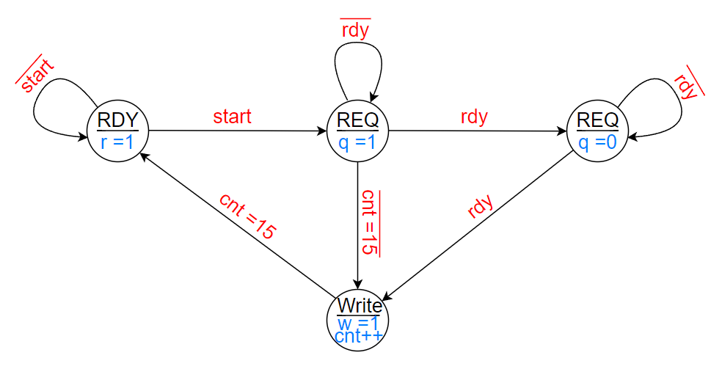

States Table :

S₁ | S₀ |  | Start | Ready | Cnt=15 |  | S₁ | S₀
0 | 0 |  | 0 |  |  |  | 0 | 0
0 | 0 |  | 0 |  |  |  | 0 | 0
0 | 0 |  | 0 |  |  |  | 0 | 0
0 | 0 |  | 0 |  |  |  | 0 | 0
0 | 0 |  | 1 |  |  |  | 0 | 1
0 | 0 |  | 1 |  |  |  | 0 | 1
0 | 0 |  | 1 |  |  |  | 0 | 1
0 | 0 |  | 1 |  |  |  | 0 | 1
0 | 1 |  |  | 0 |  |  | 0 | 1
0 | 1 |  |  | 0 |  |  | 0 | 1
0 | 1 |  |  | 1 |  |  | 1 | 0
0 | 1 |  |  | 1 |  |  | 1 | 0
0 | 1 |  |  | 0 |  |  | 0 | 1
0 | 1 |  |  | 0 |  |  | 0 | 1
0 | 1 |  |  | 1 |  |  | 1 | 0
0 | 1 |  |  | 1 |  |  | 1 | 0
1 | 0 |  |  | 0 |  |  | 1 | 0
1 | 0 |  |  | 0 |  |  | 1 | 0
1 | 0 |  |  | 1 |  |  | 1 | 1
1 | 0 |  |  | 1 |  |  | 1 | 1
1 | 0 |  |  | 0 |  |  | 1 | 0
1 | 0 |  |  | 0 |  |  | 1 | 0
1 | 0 |  |  | 1 |  |  | 1 | 1
1 | 0 |  |  | 1 |  |  | 1 | 1
1 | 1 |  |  |  | 0 |  | 0 | 1
1 | 1 |  |  |  | 1 |  | 0 | 0
1 | 1 |  |  |  | 0 |  | 0 | 1
1 | 1 |  |  |  | 1 |  | 0 | 0
1 | 1 |  |  |  | 0 |  | 0 | 1
1 | 1 |  |  |  | 1 |  | 0 | 0
1 | 1 |  |  |  | 0 |  | 0 | 1
1 | 1 |  |  |  | 1 |  | 0 | 0

States Formulas :

S₁ = S₁S₀R + S₁S₀
S₀ = S₁S₀S + S₁S₀R + S₁S₀R + S₁S₀C

Output Table :

S₁ | S₀ |  | inc | req | write | ready
0 | 0 |  | 0 | 0 | 0 | 1
0 | 1 |  | 0 | 1 | 0 | 0
1 | 0 |  | 0 | 0 | 0 | 0
1 | 1 |  | 1 | 0 | 1 | 0

Output Formulas :

Ready = S₁S₀
Request = S₁S₀
Write = S₁S₀
Increment = S₁S₀

